Project 1 - Portfolio CMS
- Project Overview
Website portfolio pribadi berbasis React sebagai frontend dan Laravel sebagai backend API, dengan dashboard admin menggunakan Filament untuk mengelola seluruh konten website secara dinamis.
Target user :
Visitor, HR, recruiter, Owner gans dan calon konglo(admin)
- Requirement Analysis
Functional Requirement
Visitor :
Melihat Hero, Melihat About, Melihat Skills, Melihat Experience, Melihat Projects, Melihat Certificate, Melihat Contact, Download CV, Kirim pesan
Admin :
Login, Logout, Dashboard, CRUD Hero, CRUD About, CRUD Skill, CRUD Experience, CRUD Project, CRUD Certificate, CRUD Social Media, CRUD Contact Info, Upload CV, Upload Image, SEO Setting, CRUD Setting, SMTP Test (opsional), Manage Site Settings

Non Functional
Responsive, SEO, Fast Loading, Accessibility, Animation, Security, REST API, Maintainable

- Tech Stack
 | Tech Stack | Peran
Frontend | React, Vite, Tailwind, GSAP, AXIOS, React Router | Menampilkan website
Backend | Laravel 12 | REST API
Dashboard | Filament | CMS
Database | MySQL
Authentication | Laravel Auth, Filament Login
Upload | Laravel Storage
Email | SMTP
Security | Cloudflare Turnstile, Rate Limiter
Deploy | Frontend : vercel  Backend : Render / Platform Cloud (TBD)  CI/CD : GitHub Actions
CI/CD | Github Actions

- System Architecture
Presentation Layer
│
├── React
│
Business Layer
│
├── Laravel REST API
│
Data Layer
│
├── MySQL
│
CMS Layer
│
├── Filament
│
Infrastructure
│
├── Vercel
├── render/railway/yg gratisan
├── Cloudflare
└── GitHub Actions
Aplikasi ini menggunakan Client-Server Architecture dengan Layered Architecture pada backend. Frontend dibangun menggunakan React, backend menggunakan Laravel REST API, data disimpan di MySQL, dan konten dikelola melalui Filament sebagai Headless CMS. Untuk deployment, frontend di-host di Vercel, sedangkan backend akan di-host pada platform cloud yang mendukung Laravel (misalnya Render atau layanan sejenis). Cloudflare digunakan sebagai DNS dan lapisan keamanan dasar.

- Database Design (ERD)
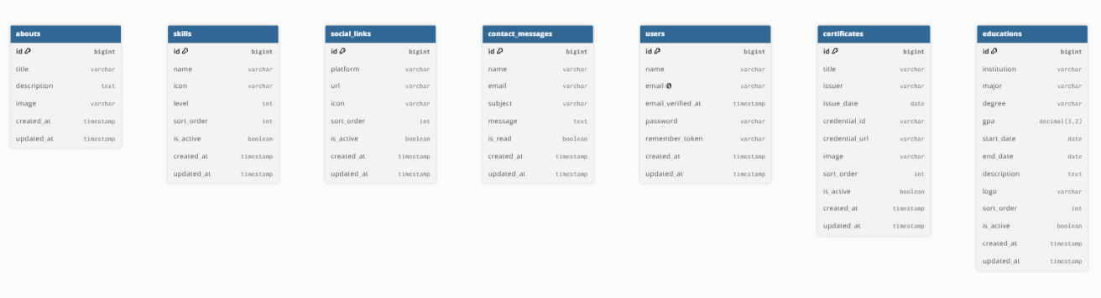
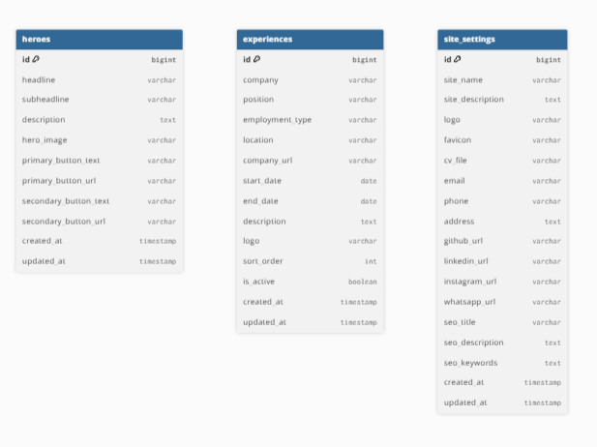

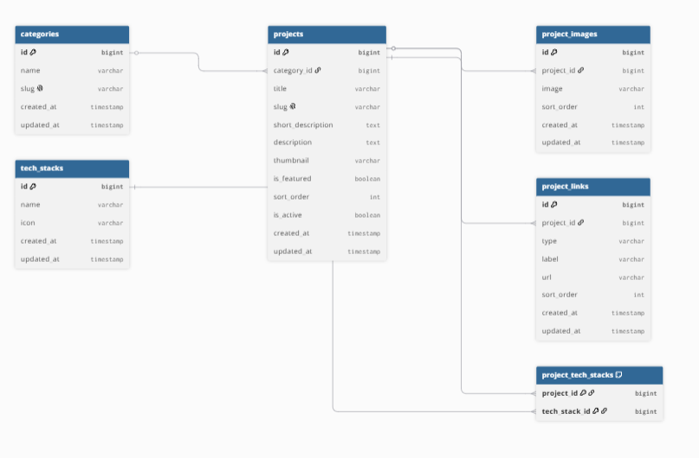

- API Design
Method | Endpoint | Fungsi
GET | /api/site-settings | Ambil setting website
GET | /api/hero | Hero Section
GET | /api/about | About Section
GET | /api/skills | Skills
GET | /api/educations | Education
GET | /api/experiences | Experience
GET | /api/projects | Project
GET | /api/projects/{slug} | Detail Project
GET | /api/certificates | Certificate
GET | /api/social-links | Social Media
GET | /api/categories | Categories
POST | /api/contact | Kirim Contact Form

- UI/UX Design
Landing Page
Navbar, Hero, About, Skill, Experience, Project, Certificate, Contact, Footer

- Folder Structure
Sesuaikan framework yang dipakai kita bagi 2 Frontend(React.js) & Backend(Laravel)

- Git Strategy
Branch :
main, develop, feature/*
Commit :
Fix : , Feat : , Refactor : , style : , Docs : , Chore : ,

- Sprint Planning
Agile Method
Planning, Backend, Frontend, Animation, Testing, Deploment, CI/CD

- Deployment
Frontend
- Vercel

Backend
- TBD (Render / Railway / Platform Gratis lainnya)

Database
- TBD (MySQL / PostgreSQL)

DNS
- Cloudflare

CI/CD
- GitHub Actions

- CI/CD
Masih rencana
GitHub

↓

Push

↓

GitHub Actions

↓

Build

↓

Deploy

↓

Production

- Security
Masih rencana

Authentication
Validation
Rate Limiter
Cloudflare Turnstile
HTTPS
CORS
Environment Variable
SQL Injection Protection (Laravel bawaan)
XSS Protection
CSRF (untuk admin panel)

- Testing
Responsive Testing : Desktop, Tablet, Mobile
Browser Testing : Chrome, Firefox, Edge
API Testing : Postman

- Future Improvement
Masih Rencana :
Dark Mode , Blog , Visitor Counter , GitHub Contribution Graph , Analytics Dashboard , Multi Language , Download Counter , Project Search , Filtering Project , Docker , Redis Cache

ROAD MAP
Requirement -> Tech Stack -> Architecture -> ERD -> API -> UI Wireframe -> Folder Structure -> Setup Laravel -> Setup React -> Filament -> CRUD API -> React Consume API -> GSAP Animation -> Contact SMTP -> Download CV -> Testing -> Deploy -> CI/CD

